Electronic System Design-ALM-4

Y. Harshavardhan
2400040454

Summary
This report summarizes the industrial visit to a site where electronic systems play a crucial role in operational activities, such as manufacturing plants with automation and process control or R&D laboratories. The visit aimed to observe electronic systems, document their architectures and work functions, analyze PCB designs, and reflect on theory-practice connections. Key observations include understanding system automation via PLCs, fault detection methods, real-time data processing, and PCB layout considerations vital for system reliability and performance.

Introduction
Electronic systems are integral to the site’s efficiency and safety, deployed in controlling manufacturing lines and testing equipment. This report details key systems observed, focusing on their architecture, control mechanisms, automation features, and PCB role.
Industrial Systems Observed

Automation System - Programmable Logic Controller (PLC) Based Control

Overview:
Automates production line controls using programmable logic controllers interfaced with sensors and actuators. The system operates under real-time feedback loops, coordinating process sequences.

Functional Blocks:

  - Input Modules (Sensor arrays)
  - PLC Central Processing Unit
  - Output Modules (Actuators, motors)
  - Human-Machine Interface (HMI) for operator control

Work Functions:

  - Real-time sensing of product positions and conditions
  - Logic processing for sequential control

PCB Role:

  - Custom PCBs house PLC CPU and I/O modules
  - Multi-layer boards with differential pair routing for signal integrity
  - Thermal management designed for harsh factory environments

Testing and Prototyping Lab Equipment

Overview:
Advanced test benches with embedded microcontrollers for automated circuit testing and prototyping.

Functional Blocks:

  - Signal Generators
  - Oscilloscopes and Meters interfaces
  - Microcontroller-based control boards

Work Functions:

  - Generate accurate test waveforms
  - Automatically measure device parameters
  - Communicate test results to PC software

PCB Role:

  - Small form factor PCBs with surface mount components
  - Sensitive analog front-ends with shielding

Schematic Symbol Examples:
  - Operational amplifiers (Op-amps)
  - High-precision resistors and capacitors

Photograph:
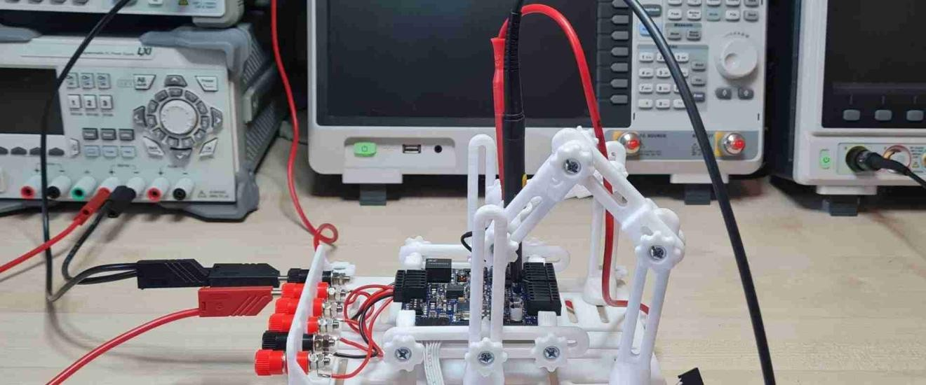

Safety and Fault Detection System

Overview:
A distributed fault detection network ensuring operational safety with sensor arrays and emergency stop functions.

Functional Blocks:

  - Sensor nodes (temperature, current, vibration)
  - Central monitoring station

Work Functions:

  - Continuous monitoring of operational parameters
  - Instantaneous fault signaling to operators

PCB Role:

  - Rugged PCBs designed for extended uptime
  - EMI shielding for noise immunity
  - Use of relay driver circuits and opto-isolators

Schematic Symbol Examples:

  - Diodes for protection
  - Relay driver transistors

  - Alarm buzzer and LED indicators
Photograph:
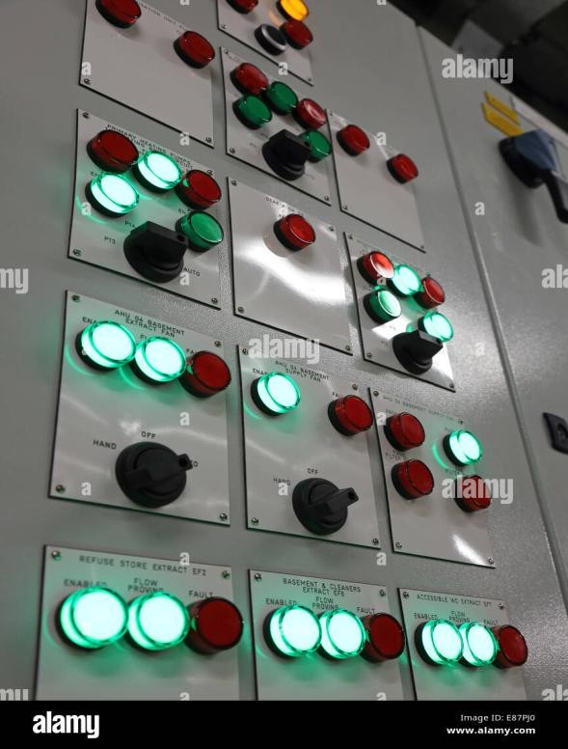

Reflections and Analysis
The visit reinforced the critical importance of PCB design in real-world systems, affecting signal quality, thermal dissipation, and mechanical resilience. The contrast with classroom environments highlighted challenges such as environmental stressors (vibration, temperature), regulatory compliance, and integration complexities. Observing interdisciplinary collaboration among electrical, mechanical, and software teams underscored the holistic nature of system design.

Conclusion:
The industrial visit provided invaluable insight into practical electronic system design, bridging theory and industrial application. To enhance future site visits, detailed schematics and component datasheets should be reviewed beforehand, and preparatory sessions on industrial communication protocols included. Strengthening industry-academic partnerships would further enrich student learning.

References
  - Site technical manuals (provided during visit)
  - Manufacturer datasheets for PLCs and sensors

